Welcome back to our old friends and “welcome” to any people who want to become new members!!
It’s once again time to renew your yearly LCW memberships. Attached is an application form for you to fill out. You may send your form and payment to Donna Dieter, membership secretary, at 9 Ridgewood Manor, Manheim, PA, 17545. Membership dues are $20/individual or $30/family. You may also pay your dues at the club meetings held at Community United Methodist Church, 130 Tennyson Dr., Lancaster, PA, the third Tuesday of each month, if that’s more convenient for you. (Note: Please do not send your checks to the church.) You will receive a new membership card when we receive payment.

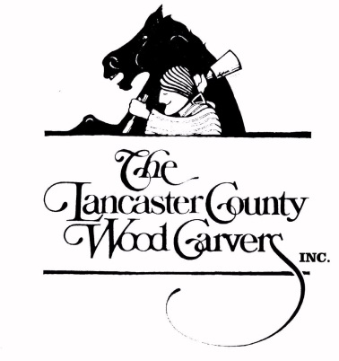
The Lancaster County Woodcarvers
2024 Membership Application

Name _______________________________________________ Phone ___________________
Address _____________________________ City ____________ State ______ Zip _________
Spouse Name (Membership Additional $10.00) ______________________________________
E-Mail Address _________________________________________________________________

Monthly newsletters will be e-mailed to you. If you do not have e-mail, it will be sent to you via USPS. Dues are $20/year. Make checks payable to: Lancaster County Woodcarvers, and send with this form to the membership secretary, Donna Dieter, at 9 Ridgewood Manor, Manheim, PA, 17545.

